

**Software Design Specification**

**[****Grocery Shop Management System]**

**Project - ICT 2212**

**Bachelor of Information and Communication Technology**

**(BICT)**

**Degree Programme**

Department of Information and Communication Technology

Faculty of Technology

Rajarata University of Sri Lanka Mihintale

**Details of the Research Project**

Title : Grocery Shop Management System

Group Number : 01

Group Name : Techno

Submission Date : 13.07.2023

Group Members :

|  |  |  |
| --- | --- | --- |
| Student Name | Index Number | Signature |
| P.W.D.I.M Rodrigo | 1357 |  |
| H.M.M.A Herath | 1313 |  |
| G.P Rockshan | 1356 |  |
| P.H.M.T Perera | 1344 |  |
| A.R.M Najas | 1335 |  |

Internal supervisor

Name : Ms. Oshadhi Munasinghe

Designation : Lecturer (Temporary)

Department : Information and Communication Technology

Email : okmunasi@tec.rjt.ac.lk

Signature : ________________ Date: _____________

**Table of Contents**

1. Introduction 5

2. General Overview 6

3. System Overview 7

3.1. Assumptions 7

3.2. Constraints 7

3.3. Dependencies 7

3.4. Risks 7

4. Design Considerations 8

4.1. Goals and Guidelines 8

4.2. Environment 8

4.3. Development Methods 8

4.4. Architectural Style/Strategies and Patterns 8

5. System Architecture and Designs 9

5.1. System Architecture Diagrams 9

5.2. Hardware Architecture 9

5.3. Software Architecture 9

6. System Design 10

6.1. Program Design 10

6.2. Database Design 10

6.3. User Interface Design 10

7. Detailed Design 11

7.1. Class Diagram 11

7.2. Sequence Diagrams 12

7.3. User Interfaces 13

8. Summary 15

9. Appendix 16

**List of Tables**

No table of figures entries found.

**List of Figure**

**No table of figures entries found.**

# 1. Introduction

In the ever-evolving landscape of the retail industry, the effective management of grocery stores has become increasingly intricate and challenging. The surge in competition coupled with evolving customer expectations has exposed the limitations of manual inventory tracking, sales monitoring, and customer management techniques. The absence of a comprehensive Grocery Shop Management System (GSMS) tailored to the distinct needs of small- to medium-sized grocery stores has resulted in escalated expenses, operational inefficiencies, and compromised customer service quality.

Grocery store owners currently grapple with a myriad of challenges, including incomplete inventory records leading to stockouts or overstocking, a lack of understanding of consumer preferences and purchasing habits, and an absence of an efficient procedure for managing suppliers and procurement. Moreover, the absence of synergy between various operational components hampers decision-making processes, impeding the overall expansion and sustainability of grocery stores.

In light of these challenges, it is evident that a reliable and user-friendly grocery shop management system is imperative. Encompassing features such as real-time inventory management, sales analytics, customer relationship management, and seamless supplier connection, such a system should cater specifically to the nuanced needs of grocery stores. The effective deployment of a GSMS is anticipated to optimize day-to-day operations, fortify decision-making capabilities, enhance customer satisfaction, and ultimately bolster the long-term survival and viability of grocery stores in the fiercely competitive retail industry.

As a response to these imperatives, the goal of this project is to conceive, develop, and implement a successful grocery shop management system tailored to the unique requirements of supermarket retailers. The overarching objective is to cultivate heightened customer satisfaction, foster data-driven decision-making, and streamline operational efficiency. This project aspires to be a catalyst for grocery businesses, empowering them to thrive in a more competitive and sustainable environment through the progressive integration of technology solutions in the retail sector.

# 2. General Overview

# 3. System Overview

## 3.1. Assumptions

## 3.2. Constraints

## 3.3. Dependencies

## 3.4. Risks

# 4. Design Considerations

## 4.1. Goals and Guidelines

1. **Efficiency:** The primary goal is to streamline customer-related processes to improve operational efficiency.
2. **Transparency:** Foster transparency by providing customers, suppliers and managers with access to relevant information such as performance goals, and company policies.
3. **Data Accuracy**: Ensure the accuracy and integrity of customer and product data through validation checks and data consistency measures.
4. **Accessibility:** Make the system accessible to all customers regardless of their location or device, promoting inclusivity and convenience.
5. **Security:** Implement robust security measures to protect sensitive customer and supplier’s information and prevent unauthorized access or data breaches.
6. **Scalability:** Design the system to accommodate growth in the number of customers suppliers and adapt to evolving business needs

## 4.2. Environment

The system will be deployed in a corporate environment. This application supports only desktop applications to accommodate diverse user preferences and usage scenarios. Our employee management system provides a digital environment for businesses to streamline tasks such as payroll, scheduling, and HR management, enhancing efficiency and organization within the workplace

## 4.3. Development Methods

1. **Agile Development:** Adopt an agile development approach to iteratively deliver features and gather feedback from stakeholders.
2. **Continuous Integration/Continuous Deployment (CI/CD):** Implement CI/CD pipelines to automate testing, deployment, and release cycles, ensuring rapid and reliable delivery of updates.
3. **User-Centered Design:** Involve end-users in the design and development process through user feedback sessions, usability testing, and user personas to create a system that meets their needs and preferences

## 4.4. Architectural Style/Strategies and Patterns

1. **Monitoring and Logging:** Incorporate monitoring and logging mechanisms to track system performance, detect anomalies, and troubleshoot issues proactively.
2. **Security Patterns:** Implement security patterns such as authentication, authorization, and encryption to protect data and mitigate security risks.
3. **Microservices Architecture:** Decompose the system into smaller, loosely coupled services that can be developed, deployed, and scaled independently, promoting agility and scalability.
4. **Service-Oriented Architecture (SOA):** Design the system as a set of interconnected services that encapsulate specific business functions, allowing for flexibility and reusability.
5. **Single Page Application (SPA):** Develop the user interface as an SPA to provide a responsive and interactive user experience, minimizing page reloads and enhancing performance.
6. **Caching Strategies:** Utilize caching mechanisms to improve system performance and reduce latency, especially for frequently accessed data

# 5. System Architecture and Designs

## 5.1. System Architecture Diagrams

## 5.2. Hardware Architecture

## 5.3. Software Architecture

# 6. System Design

## 6.1. Program Design

## 6.2. Database Design

## 6.3. User Interface Design

# 7. Detailed Design

## 7.1. Class Diagram

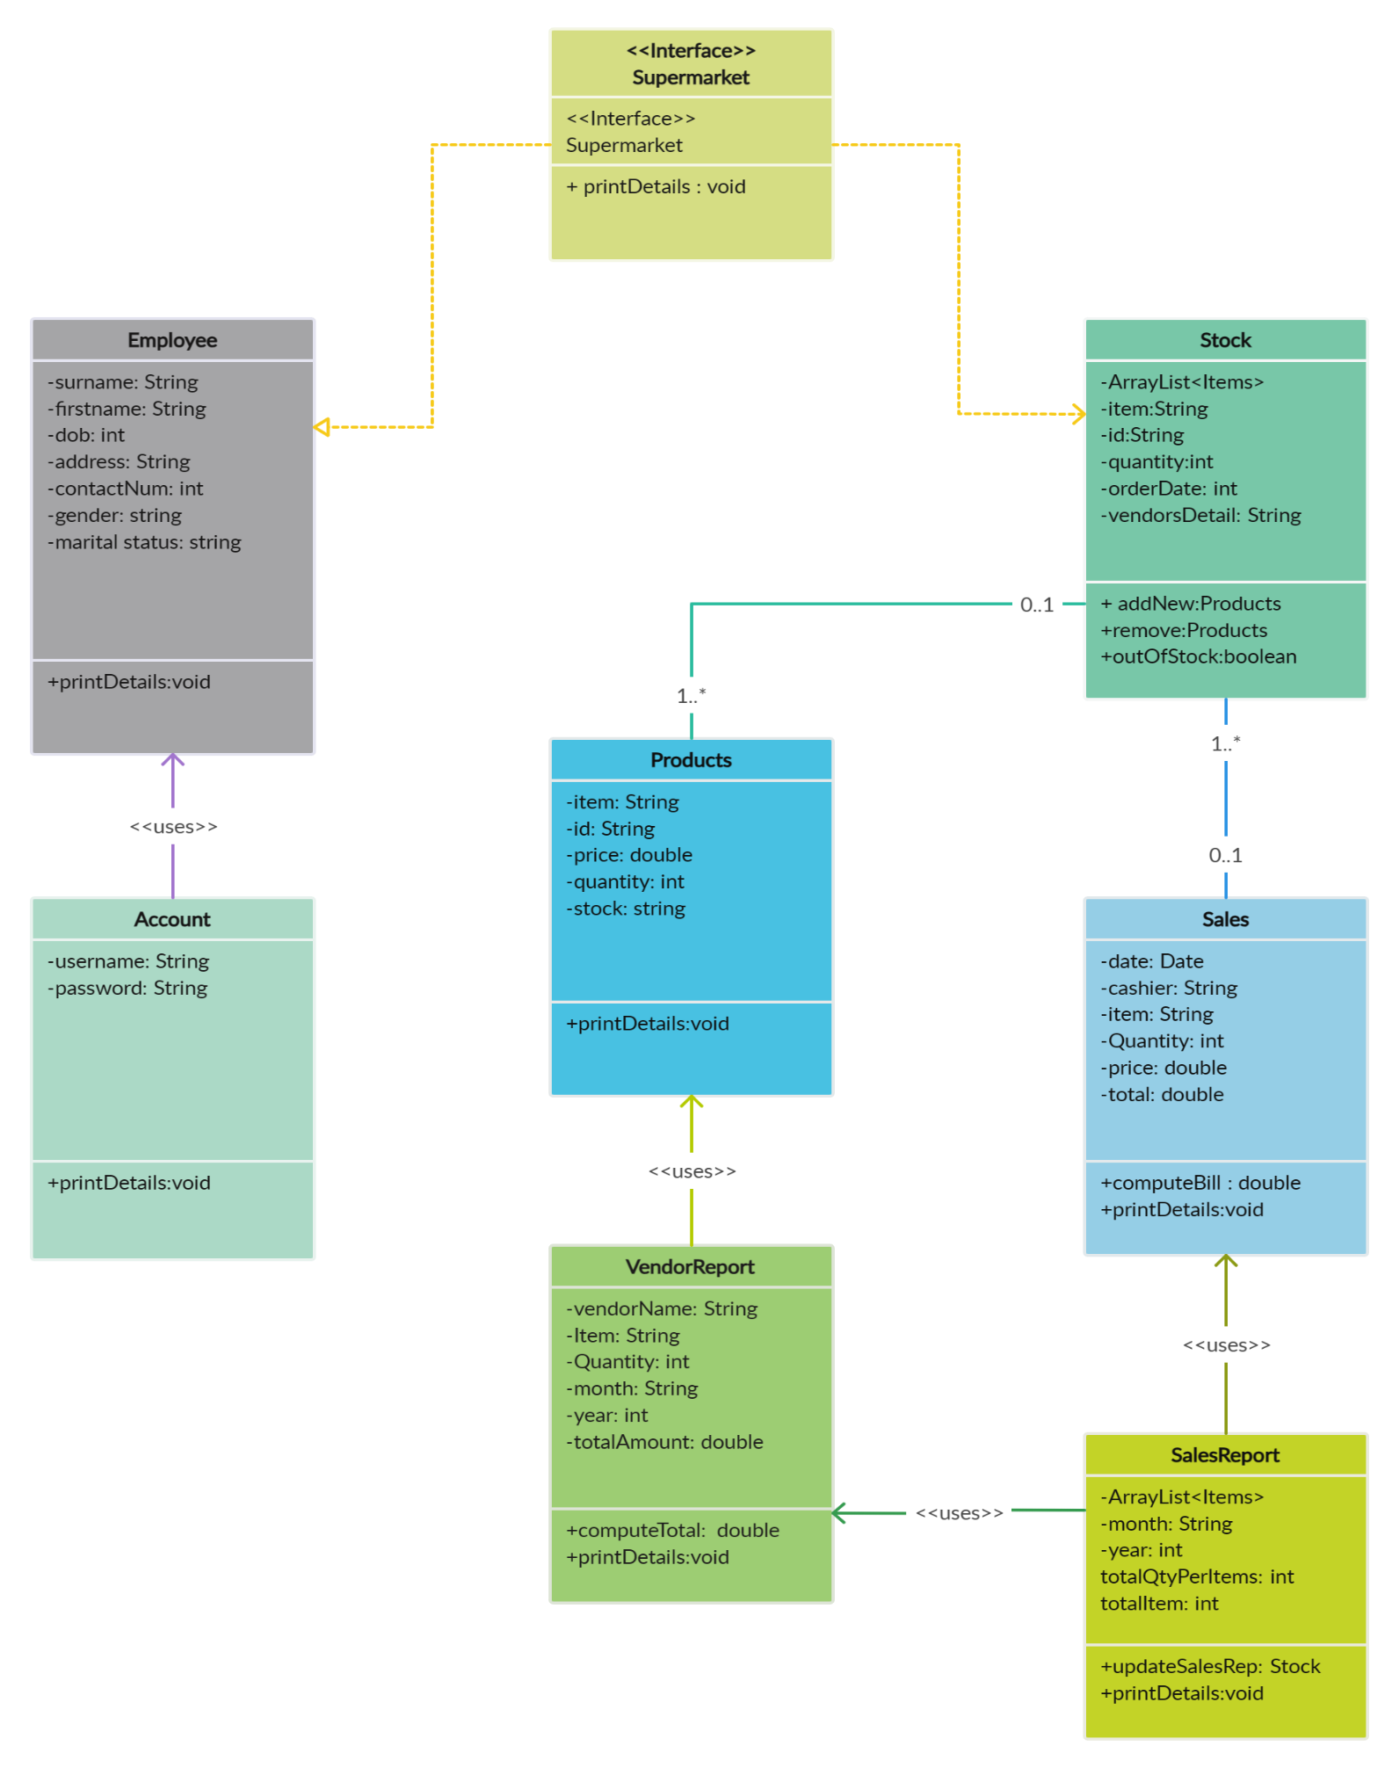

## 7.2. Sequence Diagrams

## 7.3. User Interfaces

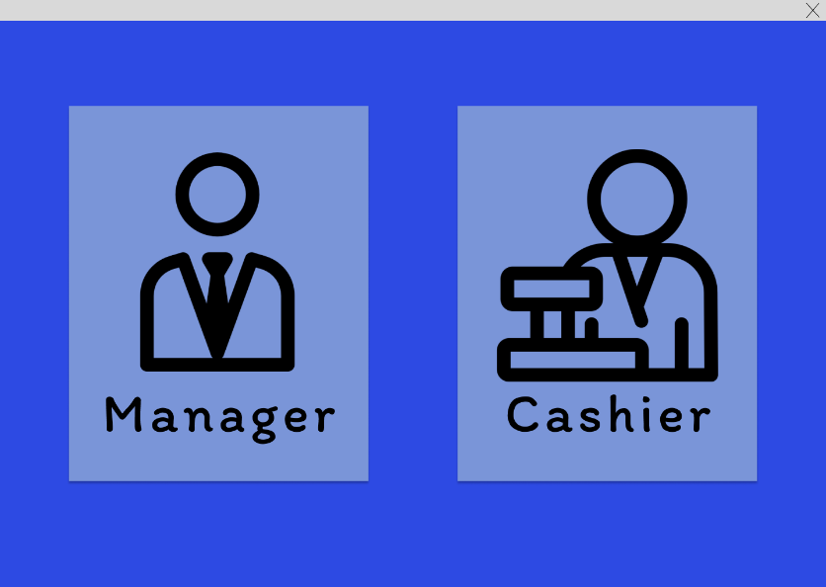

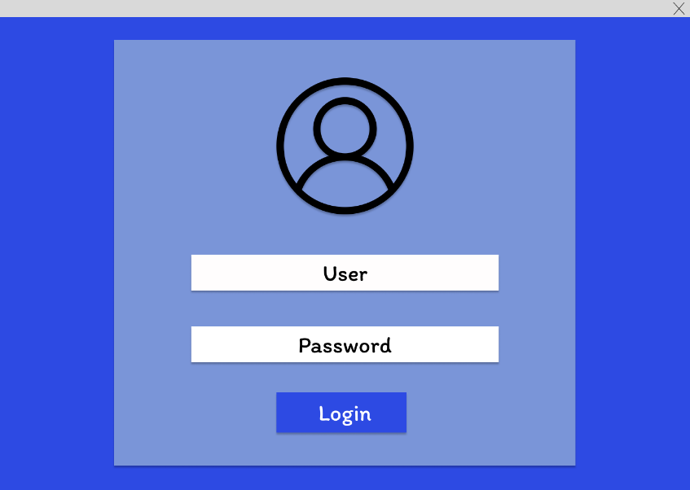

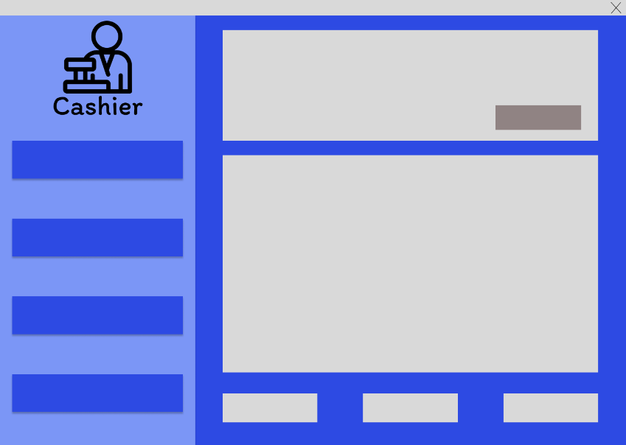

# 8. Summary

Grocery store Management System has to do with making an appropriate effort to stop the rising problem to all manual grocery store operations in order to enhance the operation of such grocery stores.

In this project, the software or system that can be used to aid all grocery stores that are still operating manually has been successfully developed. The software can be implemented in all types of the grocery store. The software has a large memory for storing all the goods in the grocery store and also keeping records it is highly effective and accurate. With business opportunities increasing as never before, companies are in direct need of efficient management.

Maintaining a methodical way to manage large databases is one of these key areas, especially in the Retail Sector. DBMS is a vital tool for the future growth of business organization. It offers a simple, efficient, and reliable way of storing, managing and accessing data.

# 9. Appendix